 | ACTION | PROCESS FOR PGR STUDENT WITHDRAWALS
 | Complete PGR Withdrawal Request Form | Access the PGR Withdrawal request form via the SharePoint site. (Please note recommended browser is Internet Explorer).  As for UG/PGT above with the following additional requirement:  - Funding [question 5 on PGR form]  The Post Graduate Centre will be notified of all PGR withdrawals/leave of absence. It is important that funding bodies are notified to allow prompt cessation of payments where appropriate.  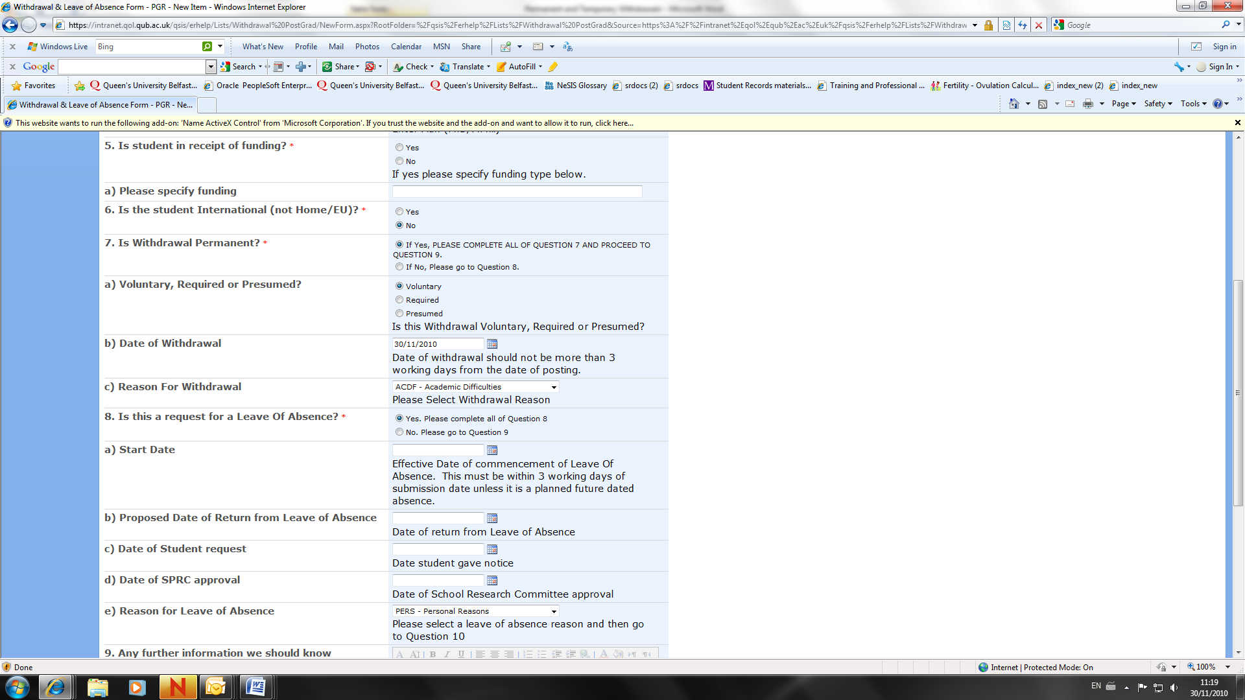

CONTACT INFORMATION:
Academic & Student Affairs
Tel: 02890 975003
Email: dasa@qub.ac.uk

Student Records
Tel: 02890 97 2727
Email: s.records@qub.ac.uk

International Student Support
Tel: 0289 097 3899
Email: iss@qub.ac.uk

